**DATABASE ASSIGNMENT:**

CREATE TABLE student (

student_id INT PRIMARY KEY,

first_name VARCHAR(50) NOT NULL,

last_name VARCHAR(50) NOT NULL,

birthdate DATE NOT NULL,

department_id INT,

address_id INT,

FOREIGN KEY (department_id) REFERENCES department(department_id),

FOREIGN KEY (address_id) REFERENCES address(address_id)

);

CREATE TABLE address(

address_id INT PRIMARY KEY,

street_address varchar(100),

city VARCHAR(50),

state varchar(50),

postal_code varchar(20)

);

create table department(

department_id INT PRIMARY KEY,

department_name VARCHAR(50)

);

**INSERTING THE VALUES:**

**DEPARTMENT TABLE:**

INSERT INTO department VALUES (1, 'Computer Science');

INSERT INTO department VALUES (2, 'Mechanical Engineering');

INSERT INTO department VALUES (3, 'Electrical Engineering');

INSERT INTO department VALUES (4, 'Civil Engineering');

INSERT INTO department VALUES (5, 'Mathematics');

INSERT INTO department VALUES (6, 'Biology');

**ADDRESS TABLE:**

INSERT INTO address VALUES (1, '123 Elm St', 'Springfield', 'IL', '62701');

INSERT INTO address VALUES (2, '456 Oak St', 'Decatur', 'IL', '62521');

INSERT INTO address VALUES (3, '789 Pine St', 'Champaign', 'IL', '61820');

INSERT INTO address VALUES (4, '102 Birch Rd', 'Peoria', 'IL', '61602');

INSERT INTO address VALUES (5, '205 Cedar Ave', 'Chicago', 'IL', '60601');

INSERT INTO address VALUES (6, '310 Maple Dr', 'Urbana', 'IL', '61801');

INSERT INTO address VALUES (7, '415 Oak Blvd', 'Champaign', 'IL', '61821');

INSERT INTO address VALUES (8, '520 Pine Rd', 'Carbondale', 'IL', '62901');

**STUDENT TABLE:**

INSERT INTO student VALUES (1, 'John', 'Doe', '1995-04-15', 1, 1);

INSERT INTO student VALUES (2, 'Jane', 'Smith', '1996-07-22', 2, 2);

INSERT INTO student VALUES (3, 'Alice', 'Johnson', '1994-11-30', 3, 3);

INSERT INTO student VALUES (4, 'Michael', 'Brown', '1997-02-19', 4, 4);

INSERT INTO student VALUES (5, 'Sophia', 'Davis', '1998-01-05', 5, 5);

INSERT INTO student VALUES (6, 'Daniel', 'Wilson', '1995-06-10', 6, 6);

INSERT INTO student VALUES (7, 'Olivia', 'Martinez', '1997-11-25', 1, 7);

INSERT INTO student VALUES (8, 'Ethan', 'Miller', '1996-03-30', 2, 8);

3.) SELECT COUNT(*) AS total_students

FROM student;

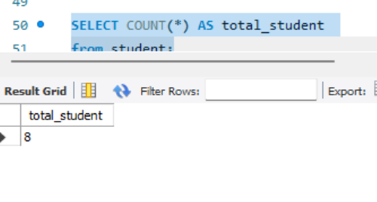

4.) SELECT s.first_name, s.last_name, d.department_name

FROM student s

JOIN department d ON s.department_id = d.department_id

WHERE s.first_name = 'John';

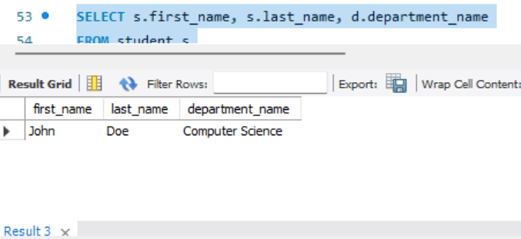

5.) SELECT d.department_name, COUNT(s.student_id) AS student_count

FROM department d

LEFT JOIN student s ON d.department_id = s.department_id

GROUP BY d.department_name;

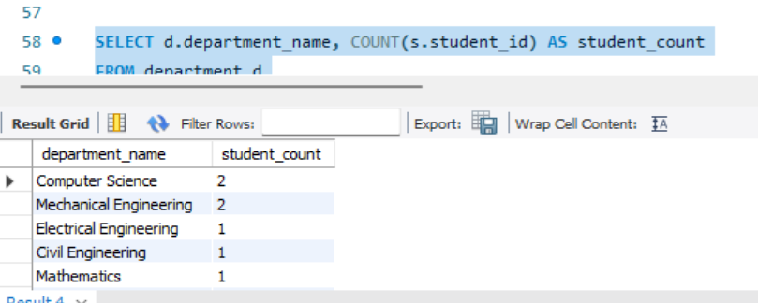

6.) SELECT

s.student_id,

s.first_name,

s.last_name,

s.birthdate,

d.department_name,

a.street_address,

a.city,

a.state,

a.postal_code

FROM student s

JOIN department d ON s.department_id = d.department_id

JOIN address a ON s.address_id = a.address_id;

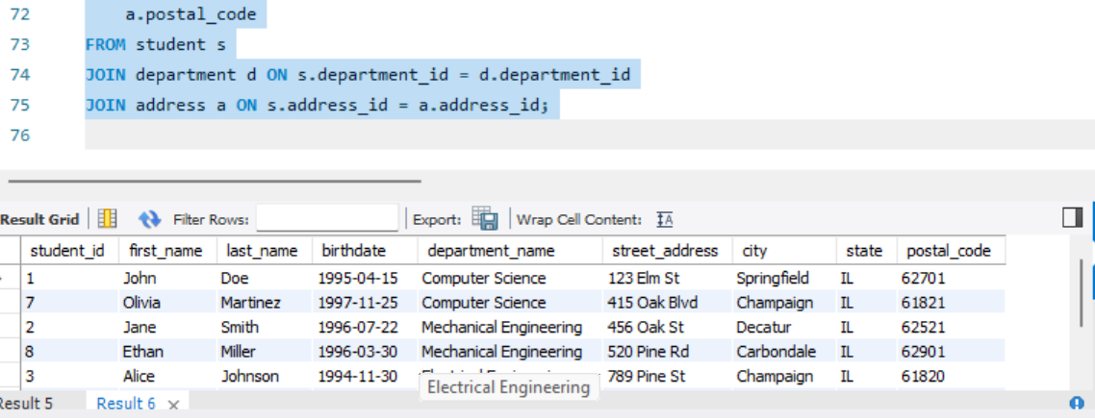

7.) SELECT

s.student_id,

s.first_name,

s.last_name,

s.birthdate

FROM student s

JOIN department d ON s.department_id = d.department_id

WHERE d.department_name = 'Computer Science';

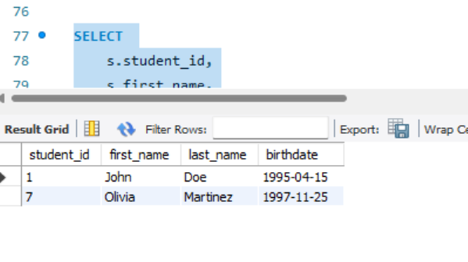

8.) UPDATE address

SET city = 'New York'

WHERE address_id = (

SELECT address_id

FROM student

WHERE first_name = 'Jane' AND last_name = 'Smith'

LIMIT 1

);

9.) DELETE FROM student

WHERE student_id = 123;

10.) SELECT

s.student_id,

s.first_name,

s.last_name,

s.birthdate,

d.department_name,

a.street_address,

a.city,

a.state,

a.postal_code

FROM student s

JOIN department d ON s.department_id = d.department_id

JOIN address a ON s.address_id = a.address_id

WHERE a.city = 'New York';

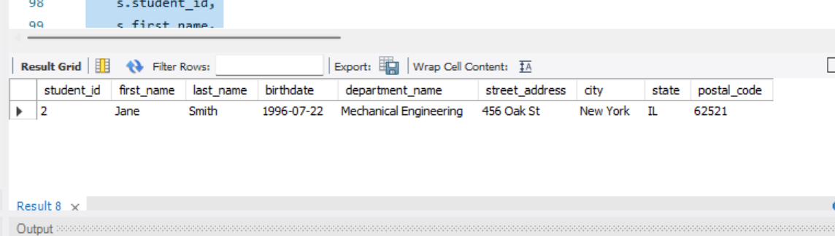

11.) SELECT

d.department_name,

COUNT(s.student_id) AS student_count

FROM department d

LEFT JOIN student s ON d.department_id = s.department_id

GROUP BY d.department_name;

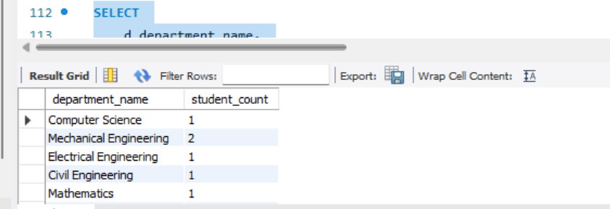

12.) SELECT

s.student_id,

s.first_name,

s.last_name,

s.birthdate,

a.street_address,

a.city,

a.state,

a.postal_code

FROM student s

JOIN address a ON s.address_id = a.address_id

WHERE a.city = 'Springfield';

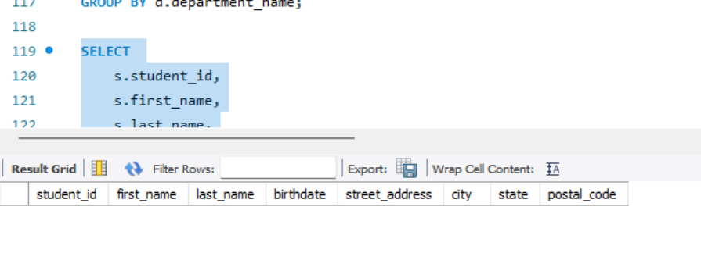

13.) SELECT

student_id,

first_name,

last_name,

birthdate

FROM student

WHERE MONTH(birthdate) = 2;

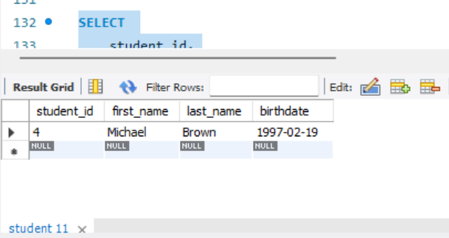

14.) SELECT

s.student_id,

s.first_name,

s.last_name,

d.department_name,

a.street_address,

a.city,

a.state,

a.postal_code

FROM student s

JOIN department d ON s.department_id = d.department_id

JOIN address a ON s.address_id = a.address_id

WHERE s.first_name = 'John';

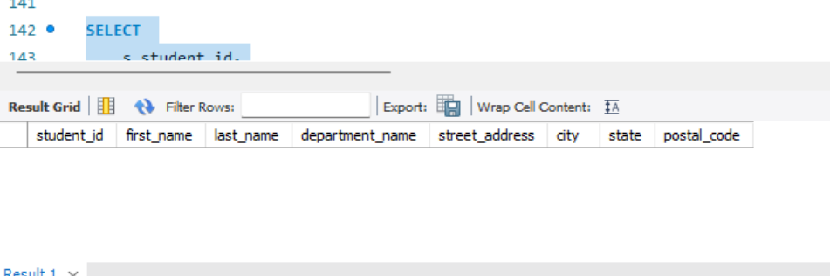

15.) SELECT

student_id,

first_name,

last_name,

birthdate

FROM student

WHERE birthdate BETWEEN '1995-01-01' AND '1998-12-31';

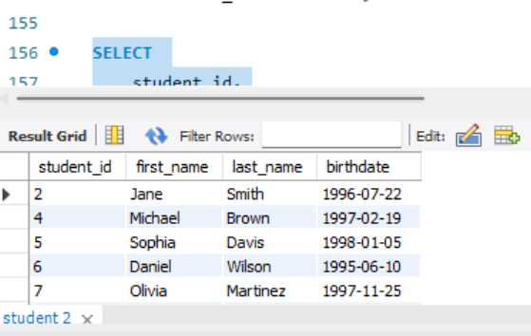

16.) SELECT

s.student_id,

s.first_name,

s.last_name,

d.department_name

FROM student s

JOIN department d ON s.department_id = d.department_id

ORDER BY d.department_name;

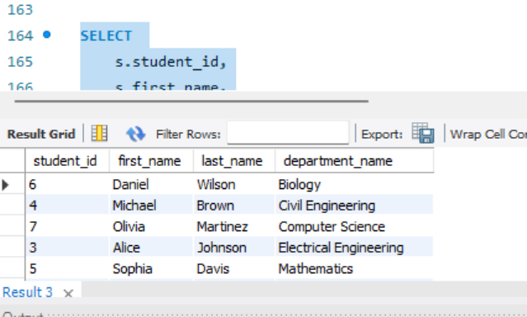

17.) SELECT

d.department_name,

COUNT(s.student_id) AS student_count

FROM student s

JOIN department d ON s.department_id = d.department_id

JOIN address a ON s.address_id = a.address_id

WHERE a.city = 'Champaign'

GROUP BY d.department_name;

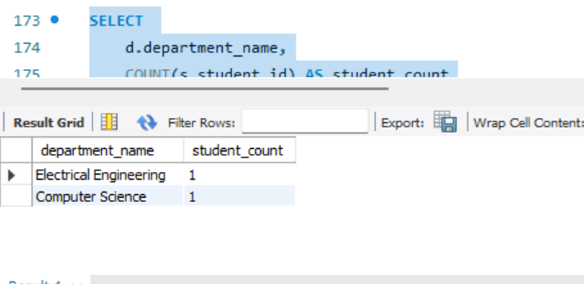

18.) SELECT

s.first_name,

s.last_name,

a.street_address

FROM student s

JOIN address a ON s.address_id = a.address_id

WHERE a.street_address LIKE '%Pine%';

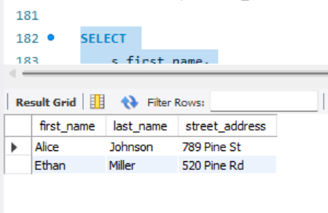

19.) SELECT

s.student_id,

s.first_name,

s.last_name,

d.department_name

FROM student s

JOIN department d ON s.department_id = d.department_id

WHERE s.student_id = 6;

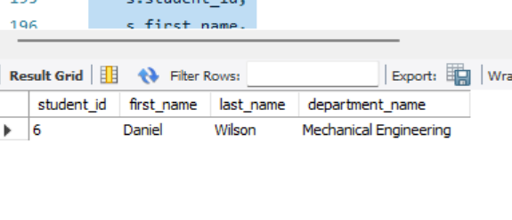

20.) SELECT

s.student_id,

s.first_name,

s.last_name,

d.department_name,

a.city

FROM student s

JOIN address a ON s.address_id = a.address_id

JOIN department d ON s.department_id = d.department_id

WHERE a.city = 'Chicago'

AND d.department_name = 'Mathematics';

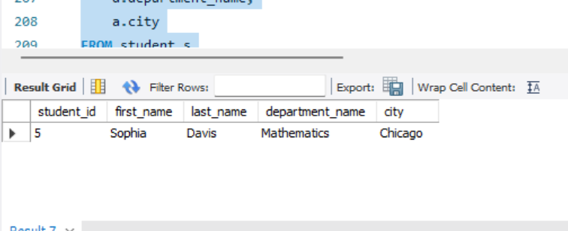

21.) SELECT

s.student_id,

s.first_name,

s.last_name,

a.street_address,

a.city,

a.state,

a.postal_code

FROM student s

JOIN address a ON s.address_id = a.address_id

WHERE a.city IN ('Urbana', 'Peoria');

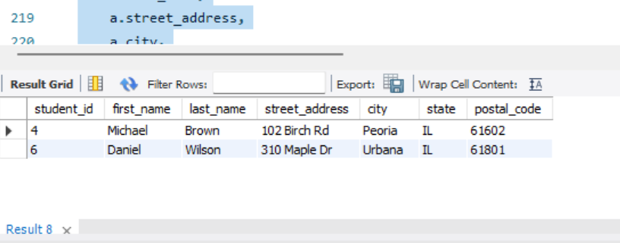

22.) SELECT

student_id,

first_name,

last_name,

birthdate

FROM student

ORDER BY student_id DESC

LIMIT 1;

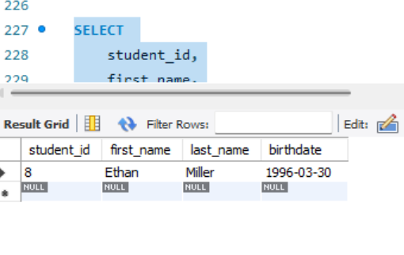

23.) SELECT

s.student_id,

s.first_name,

s.last_name,

d.department_name

FROM student s

JOIN department d ON s.department_id = d.department_id

WHERE d.department_name <> 'Computer Science';

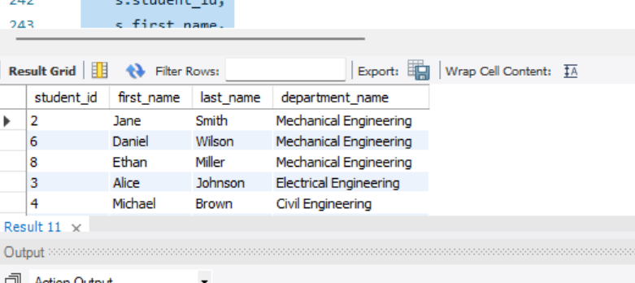

24.) SELECT

COUNT(*) AS total_addresses

FROM address

WHERE city = 'Champaign';

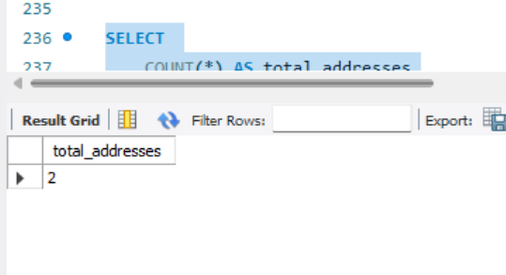

25.) SELECT

s.first_name,

s.last_name,

a.street_address

FROM student s

JOIN address a ON s.address_id = a.address_id

WHERE a.street_address = '520 Pine Rd';

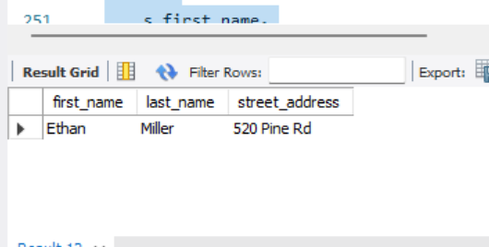

26.) SELECT

AVG(TIMESTAMPDIFF(YEAR, s.birthdate, CURDATE())) AS average_age

FROM student s

JOIN department d ON s.department_id = d.department_id

WHERE d.department_name = 'Electrical Engineering';

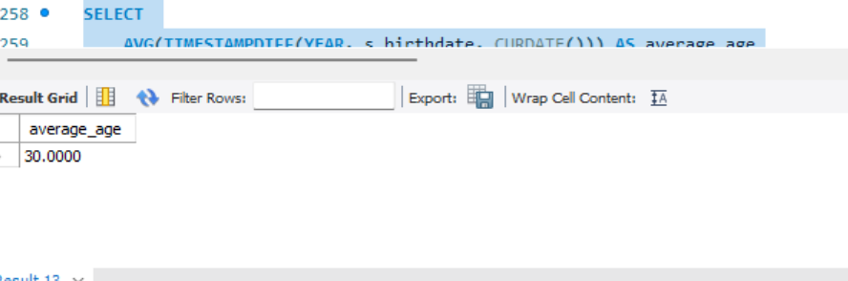

27.) SELECT

AVG(TIMESTAMPDIFF(YEAR, s.birthdate, CURDATE())) AS average_age

FROM student s

JOIN department d ON s.department_id = d.department_id

WHERE d.department_name = 'Electrical Engineering';

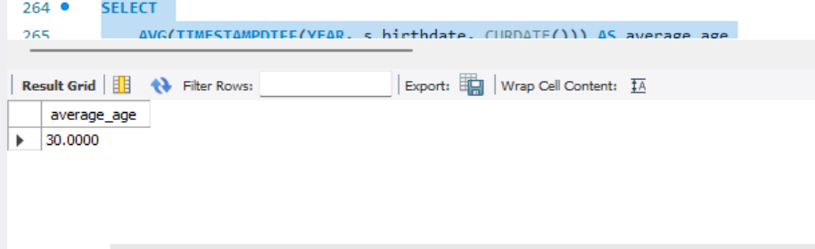

28.) DELETE FROM student

WHERE department_id = (

SELECT department_id

FROM department

WHERE department_name = 'Mechanical Engineering'

)

LIMIT 1;

**Part-2:**

1.) 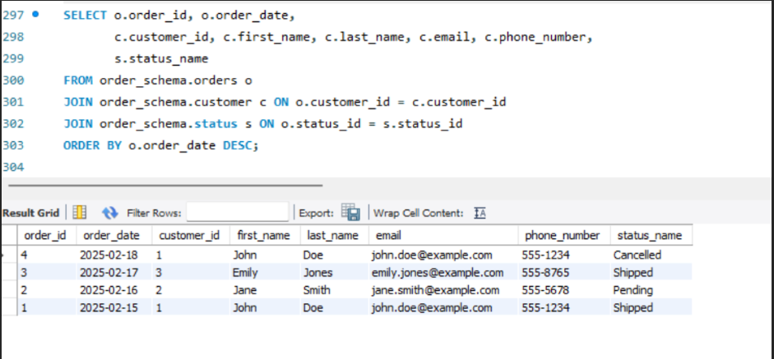

2.) 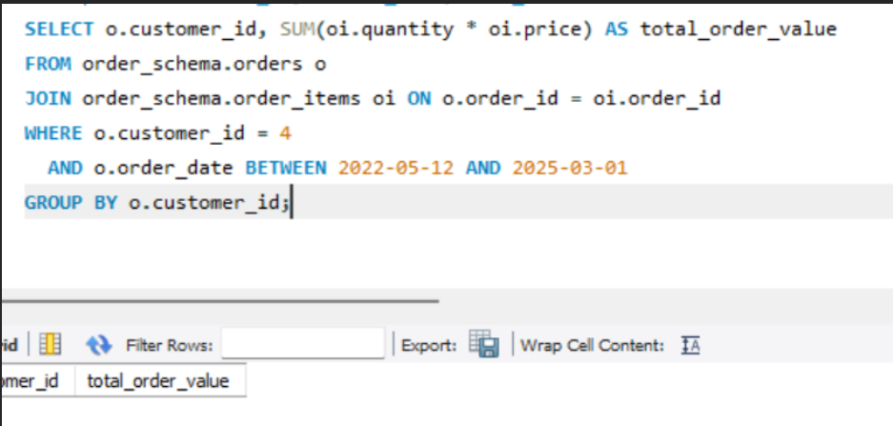

3.)

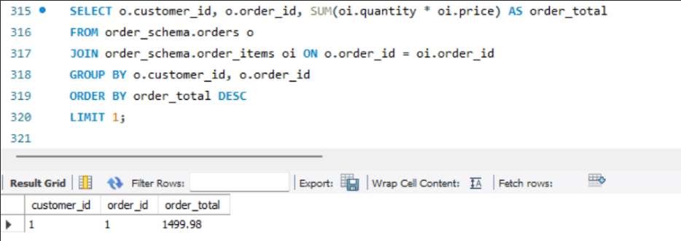

4.)

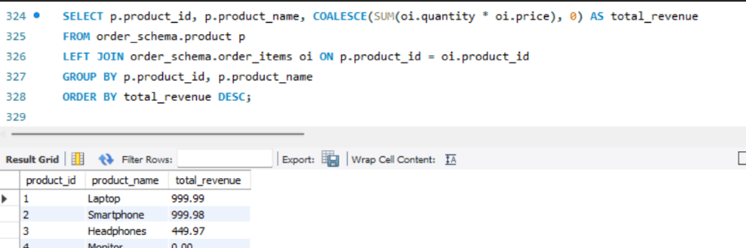

5.)

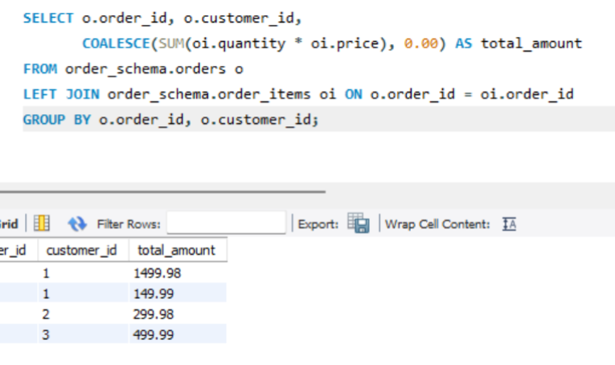

6.)

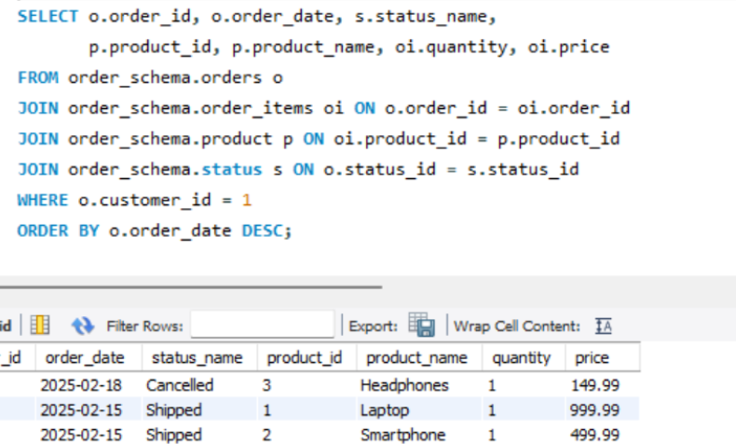

7.)

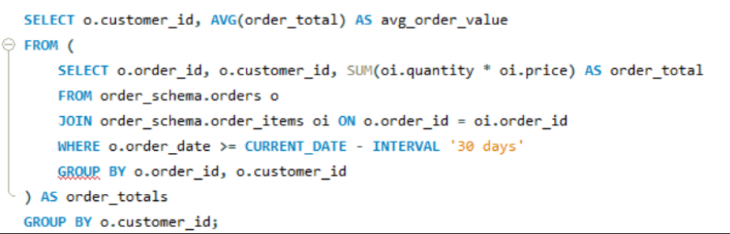

8.)

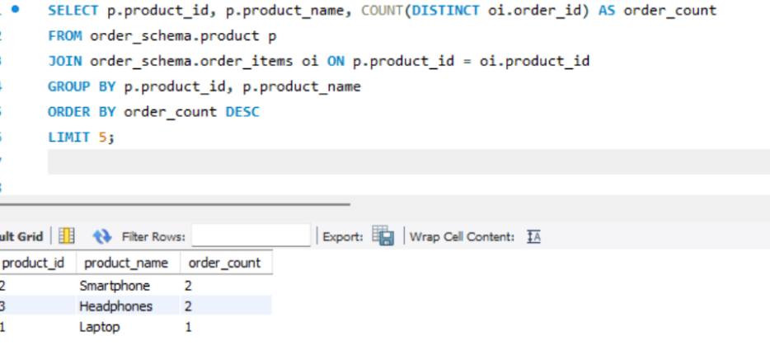

9.) 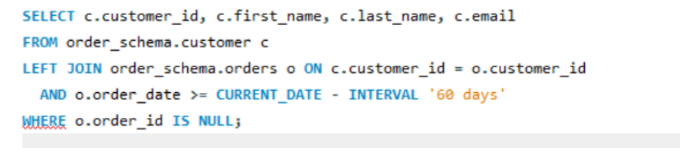

10.)

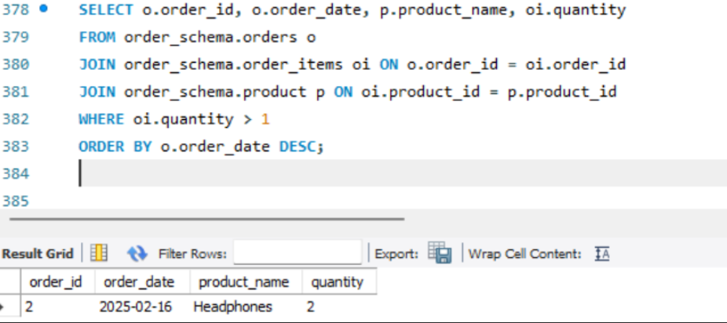

11.)

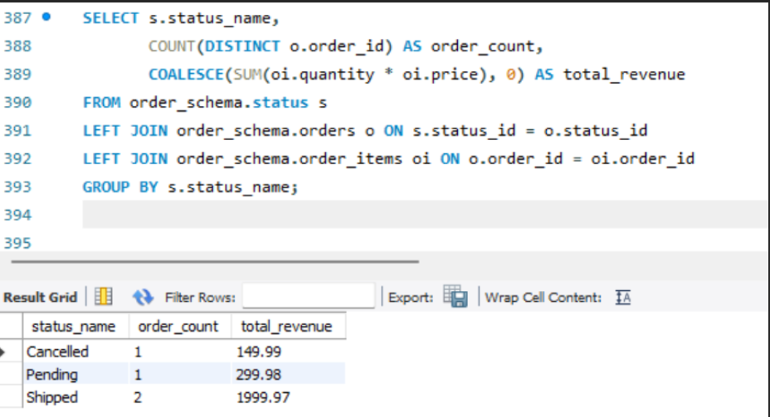

12.)

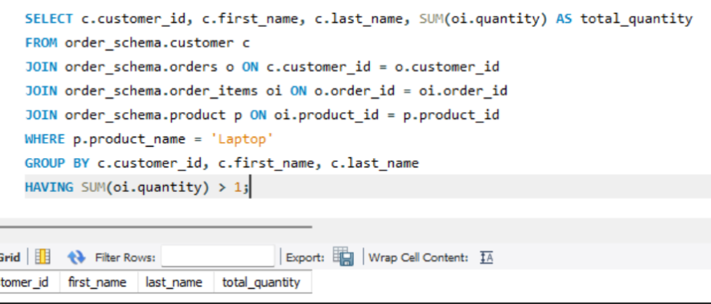

13.)

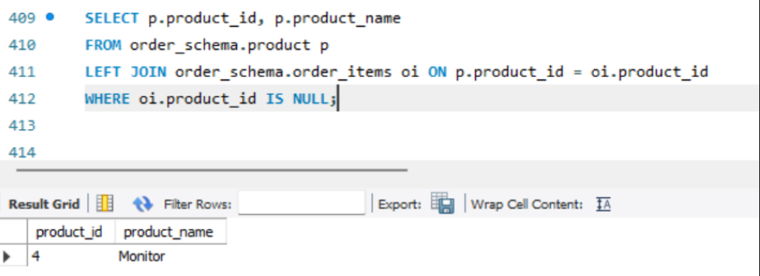

14.)

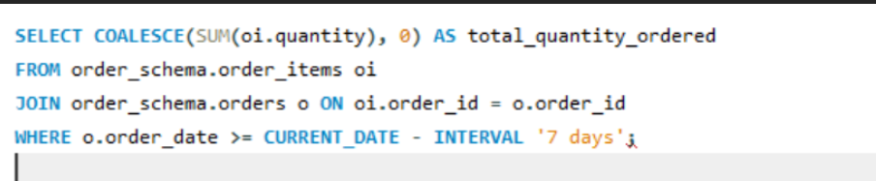

15.)

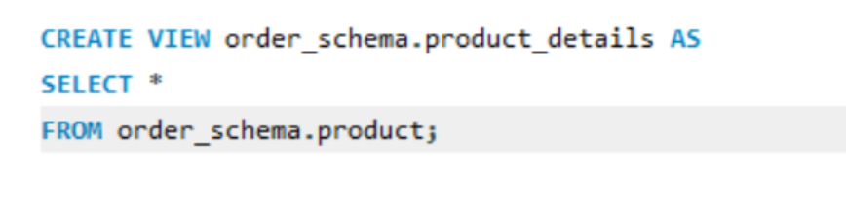

16.)

